Mecca Glen School
Together We Are Making A Difference

Wolf Creek Public Schools

Shannon Quapp
School Council Chair
RR #1 Telephone (403) 783-2463
Ponoka, AB Fax (403) 783-6666
T4J 1R1

School Council Meeting Minutes
Thursday, January12, 2017–7:00 pm
In Attendance: Kari A., Dan W., Amanda N., Richard Z., Jason S., Nicole B., Kristi P., Dawn K., Donna P., Willem H., Laureen S., Shannon Q., Greg M., Stacy W.

- Call to Order @ 7:04 pm

- Approval of Agenda – Dawn K. motioned to approve agenda as presented, seconded by Nicole B.

- Minutes From Last Meeting – Dawn K. motioned to approve minutes as presented, seconded by Laureen.

- Business Arising from the Last Meeting
  - Accelerated Reader – Mr Zandberg gave a description of what the AR program is. Central office no longer covers the cost of the program. Fundraising Society is going to pay for the license this year. Thank you Fundraising Society! Mr. Walker is going to look into cost sharing with another school for next school year.
Last year was the first year the prizes where scaled back, each room had their own ‘reading party’; this seemed to be good with staff and students. There are prizes remaining from previous years that are available for classroom teachers to utilize this year.

  - Grade 9 Bottles – someone helped themselves to the bottles from the trailer, there were not many bottles left to do anything with. Perhaps the Grade 9 will look into contacting Ponoka Bottle Depot and see if they would be willing to help do a bottle drive.

  - Grade 9 Trip - Frontier Lodge, Pastor Ted may be going along as an extra chaperone, leaving on May 28. The Grade 9’s will be preparing and serving a meal at the Edmonton Mustard Seed, this will be on Tuesday or a Wednesday evening, no date set yet.

  - No smoothie days until a coordinator is found.

  - Cultural Days – staff will be working on planning this after report cards go home.

- Treasurer’s Report – Stacy Waddell
General Account: $20,907.70
General Business Savings: $29,290.26
Casino Account: $413.02
Casino Savings: $88.11
Ponoka County will provide $1500.00 to support the rink. Thank you Ponoka County
Nicole will look at the cost of new hockey nets and provide fundraising society with a quote.

- Fundraising Society Report –Willem Huyssoon
Christmas raffle was a success, all the tickets sold. Congratulations to the winner.
Next fundraiser is Coco Brooks.
Bashaw meats in spring.
Highway clean up in May.
Casino is on January 17 & 18, all spots are filled for volunteering. Thank you to everyone who signed up to help!
Taller chairs or benches for the gym for seating during sporting events –this is still being looked into.

- School Board Trustees’ Report – Donna Peterson
January 5, 2017 Meeting Cancelled
The Wolf Creek Public Schools’ Division Office will be closed from December 24, 2016 through January 6, 2017. Due to this closure the Board Meeting for January 5, 2017 has been cancelled. The next regular meeting for the Board will be held on January 19, 2017.

Bright Futures Play Academy to Continue in 2017/2018
The Board of Trustees reviewed information on the Bright Futures Play Academy that was started this fall to support programming for approximately 375 three and four year old children in 7 schools across WCPS. The board expressed appreciation for the initial success of this program as it assists with a focus on supporting early learning needs. On the basis of program participation and to facilitate the advertising for the program for the fall 2017 the Board approved the continued operation of the program to be included in the 2017-2018 operating budget.

ASBA Rural Organization
Alberta School Boards Association is an association dedicated to advancing and advocating for Alberta school boards. Presently all boards in Alberta are members of the Association. In recent times there has been a movement to create a greater voice for the plight of rural school jurisdictions and bring focus on the issues that are experienced by rural boards. An opportunity to join the proposed Rural School Boards’ Organization and the Board accepted the opportunity. Through joining our board desires for the specific needs of rural boards’ to be fully advocated for as unique entities on the provincial education scene.

Next School Council meeting should have results of the Thoughtexchange
Carbon Tax – School Boards may qualify for rebates for heating and diesel bussing.
Public Health Act has been amended to allow Alberta Health to get student information from school boards for use in contacting parents directly.
Former Superintendent Larry Jacobs passed away. On Saturday January 21, there will be a celebration of life at Lacombe Composite High School.

- Playground Update –Kari Albers
Still working on recognition plans for the sponsors.

- Principal’s Report – Dan Walker
December was a busy month we had some great events take place within the school over the last weeks before the holidays. The White Elephant Sale which made over $400, Christmas Concert, School Potluck were all successes. Richard, Tristan and I hosted a bus driver's breakfast to show our appreciation and help maintain communication lines. The Alberta Opera came and put on another great performance enjoyed by the whole school. One of the more interesting highlights of the month was the Boil Water Advisory the school was placed under. A water sample from the school is taken each week to be tested to ensure its safety. Following some work to our system we failed one of the tests, this prompted the advisory to be put in place. The problem was fixed by adjusting the chlorine levels within the test result being received. Although the problem was solved the advisory cannot be lifted until the government official comes to inspect the site and two more water samples taken on different days are tested and pass. The school division supported us by bringing in bottled water for every student and we set up bottled water stations in the hallway for students to refill water bottles.

This month we are gearing up for ski day on the 24th, currently we have over 80 students registered to attend the hill. We love how many parents attend the hill on this day and as a staff are strongly encouraging parents of the K, 1, 2’s to attend on this day. We have a second ski day planned in February but it won’t be confirmed until we get an idea of student numbers. Report Cards? Checklists and Portfolio’s are going home on the 31st of January with Parent Teacher Interviews the following Thursday. Accountability Pillar Survey’s will start being sent out near the end of the month for parents and Grade 4-9 students as well as staff will be filling them out before the end of February. The Thoughtexchange data which gathered responses last fall from school stakeholders has been compiled and the data set will be looked at by the Wolf Creek Admin. Exec to determine a course of action for addressing some of the major themes presented. Once we have direction on how the data will be used we will present it to School Council. In the next few weeks we will be completing the second round of STAR testing for our students in Grades 3-9. This is a quick screen to determine growth in the area of reading and comprehension.
The basketball season is in full swing and we look forward to hearing more on the development and success of our teams. We will be adding an additional night of the week for the Grade 6/7 boys to practice and develop their skills. The new basketball hoops have arrived for the side walls in the gym, they will be hung by the division facilities department hopefully sooner than later. Our curling season is starting up and Dan Lea has once again volunteered to coach our teams. The current 6-9 options classes are Drama, Scobotics (Scale Design and Robotics) and basketball Intermediate level.

- New Business
  - Discussion/Update on Recent School Activities –
    - Water Concerns at the School – please see Principal’s report.
    - Alberta Opera – it was really good, kids all enjoyed it.
    - Christmas Concert – good, some of the sound was hard to hear. Will look into a different set up for next year, it was great to see some of the older students participating.
    - White Elephant Sale – good, made about $400.00. ½ was donated to the Ponoka Food Bank and the other ½ was donated to Old MacDonald Kennels, they asked to have their ½ donated to the Grade 9 trip. Thank you!
It was hard to find parent volunteers this year, better communication is needed when volunteers are needed. Volunteers need to have a valid Criminal Record Check on file at the school. Some older kids feel like there is not much left to pick from when they get their turn, maybe look into rotating which grade’s go first?
    - Christmas Potluck – went well, maybe look into having parents serve kids instead of kids helping them selves.
    - Sports Activities – going well
    - Olweus – still have classroom meetings, rules, anti-bullying is still very important. In the spring, staff will be looking into how to make it more than just about bullying. Olweus has made Mecca a very safe, caring school.
  - Discussion of Upcoming School Activities –
    - Ski Days – January 24 is a go, still need a large turn out to make the February one a go.
    - Winter Walk Day – Will happen in February
    - Field trips – Approved for the Drumheller field trip for Grades 3, 4, 5. Legislative for Grade 6 -9 in the spring. Staff are working on a field trip for the younger group also.

  - Skating Rink and Hockey Nets – Tuesdays at lunch kids can skate. Plunkett’s are doing a great job. Thank you so much! Check the light bulbs please.
Stacy motioned we should look into purchasing new hockey nets for the skating rink. Seconded by Nicole. Passed.

  - School Council E-News:(ASCA)
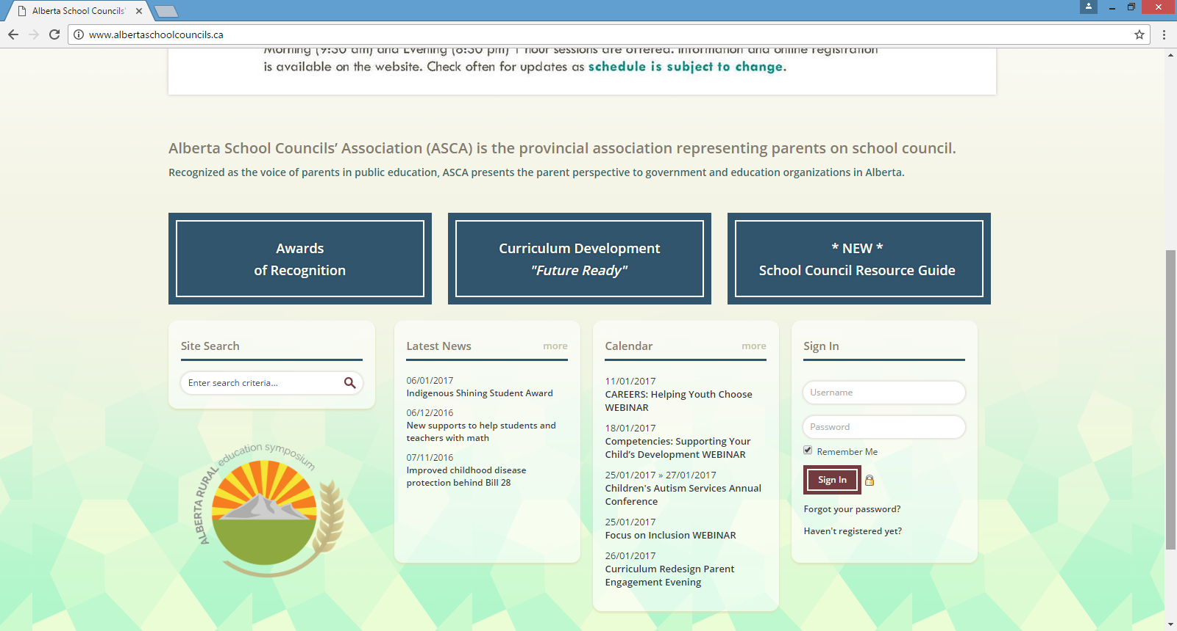
http://www.albertaschoolcouncils.ca/news/320916/New-supports-to-help-students-and-teachers-with-math.htm
As part of the Future Ready initiative, the government is taking steps to help students achieve better marks in math and assist teachers in mathematical instruction.
Starting in 2018, high school mathematics diploma exams will once again require students to show their work. This portion of the exam was removed in 2010 by the previous government as a cost-saving measure. Alberta Education will also introduce a non-calculator portion to the Grade 9 Mathematics Provincial Achievement Test.

Teachers will soon have access to up to $2,000 to help cover tuition costs for post-secondary courses designed to strengthen their knowledge, skill and confidence in teaching mathematics. Details of the program are being finalized.

Alberta Education will allocate at least $2 million toward these actions through its existing budget.
“We will work diligently to improve our math scores by reinforcing basic skills and by introducing new programs. Strong math skills are key to success in learning.”
David Eggen, Minister of Education
  - Other

- Mailbag - Empty
- Next Meeting – March 2, 2017 @ 7:00
- Adjournment – 8:44 pm

