Mecca Glen School
Together We Are Making A Difference

Wolf Creek Public Schools

Shannon Quapp
School Council Chair
RR #1 Telephone (403) 783-2463
Ponoka, AB Fax (403) 783-6666
T4J 1R1

School Council Meeting Minutes
Wednesday, November 2, 2016 – 7:00 pm
In Attendance: Kari A., Tristan J., Dan W., Stacy W., Dawn K., Greg M., Jason S., Shannon Q., Donna P., Deb W., Laureen S.

- Call to Order @ 7:04 pm

- Approval of Agenda – Tristan motioned to approve to agenda as presented, Dawn seconded.

- Minutes From Last Meeting – Tristan motioned to approve to minutes as presented, Stacy seconded.

- Business Arising from the Last Meeting –
Playground meeting was not held in October, planning one for November or December.
Grade 9 trip – meeting next Tuesday to discuss a new trip location.
Alberta Culture Day – school is working on a plan.

- Treasurer’s Report – Stacy Waddell
General Chequing: $16,324.15
Casino Chequing: $8,290.64 (most of the casino money has been spent just hasn’t shown up on the account yet.)
Casino Dates – January 17 & 18, 2017 Sherri Kroening is looking for volunteers.
Ponoka County – we are still waiting to hear back if they will donate money for the skating rink to help cover costs again this year, should know soon.

- Fundraising Society Report – Willem Huijssoon presented by Dawn Kroening
Tickets for trip raffle are on sale, Kristy Padgham is looking after this fundraiser.
Field trip money has been upped to $45 per student.

- School Board Trustees’ Report – Donna Peterson
WCPS Enhanced Learning Model
Greg Esteves, Director of Technology Integration and Sean Lougheed, Director of Learning Services presented on the new WCPS Enhanced Learning Model that has been implemented in two small high schools operating in WCPS. This implementation is a result of the work of 10 master teachers that curated the course content in 25 core high school courses during the summer in preparation for the 2016-17 school year. The model provides potential opportunities for students and teachers in small rural high schools to access an enhanced set of educational core programming supports which supports learning. Many small high schools have lower numbers of students per core academic course, resulting in a single teacher being responsible for multiple core courses simultaneously. The Enhanced Learning Model is designed for both students and teachers in accessing strong learning and instructional supports.

Changes to Rural Transportation Procedures
Superintendent Lovell discussed with the Board the current procedures in place for rural transportation pick-up and drop-off locations. In response to concerns raised by various families asking for more flexibility in these locations Mr. Lovell advised that there will be a slight relaxation of the procedures. Families will now be able to access alternative stops along the established routes to provide some flexibility. The change will not accommodate those wishing to access more than one bus route as the Division does not have the capacity to offer this throughout the jurisdiction based on space availability and distances being travelled. The changes will be communicated out to parents as soon as possible.

Rimbey Walking Trail
The Board approved a request from the Town of Rimbey to allow a walking trail to be constructed on the west edge of the Rimbey Junior Senior High School property. The trail will connect the existing trail on the north side with the arena parking lot.

Concussion Protocol
Wolf Creek Public Schools will be developing a protocol to deal with concussions occurring in students. The protocol will deal with student athletes and other students in determining the appropriate return to activity for each student. Concussions have become a major topic of concern and discussion throughout school jurisdictions and amateur sports. The health of our students is paramount and must be protected to the extent possible.

Bill C241 Letter of Support
Bill C241 is a private members bill in the House of Commons that seeks to have school boards receive a 100% rebate on GST that is paid on goods and services. Currently school boards in Canada receive a rebate of 68% of the GST paid. Approval of the bill would move school boards to the same status as municipalities in Canada. WCPS will send a letter of support to the Minister of Finance, local MP Blaine Calkins and MP Kevin Waugh, Saskatoon—Grasswood, who originated the bill.

Modular Classroom Applications
WCPS will be requesting four modular classrooms from the provincial government to provide needed programming space in two schools. Two classrooms will be requested for the Iron Ridge Elementary Campus and two will be requested for the Terrace Ridge School. If approved the classrooms would be ordered and installed in the summer 2017.

Administrative Procedure Review
WCPS will be contracting the services of the Alberta School Boards Association to undertake a complete review of all current Administrative Procedures. The review will ensure that WCPS Administrative Procedures are up to date and meeting the current requirements contained in the School Act and Regulations.

First Nations Land Acknowledgement
Starting immediately all board meetings and functions will begin with the reading of a First Nations Land acknowledgment. The acknowledgement reads as follows:
“We acknowledge that we are on Treaty Six territory and we recognize all the many First Nations, Metis, Inuit and non-First Nations whose footsteps have marked these lands.”

Central Alberta Regional Consortium Presentation on Curriculum Changes
On October 27, 2016 at 6:00 p.m. Central Alberta Regional Consortium (CARC) will host an information session at the Ѐcole Secondaire Lacombe Composite High School regarding proposed changes to the education curriculum in Alberta. The session is open to anyone in the Division. CARC will be providing a meal with the presentation. Prior registration is required and can be done through Mrs. Jackie Haines in our division office. Jackie can be contacted at 403-783-3473 or jackie.haines@wolfcreek.ab.ca.

- Principal’s Report – Dan Walker
News and Events
The month of October flew by and we have had a number of successes. We raised a lot of money for our annual Terry Fox Walk and are currently following through staff made as promises for students fundraising. We had students who became Principal for a day and changed rules and ran an assembly. Mr. Troitsky donned some feminine attire for a day and I am growing and keeping a mustache until December. Our last reward is the Principal's dinner in town for the student and one friend who raised the most money in Grade 6-9. Volleyball season is nearing its end, the girls team has finished and the boys team is off playing in what may be their final tournament tonight. We also held a Poetry Slam for many of the students in Grade 6-9. Those are just a couple of the highlights and they will continue as we move through November. The Remembrance Day Ceremony will be held on the 8th at 11:00, the Alberta Opera is coming on the 24th, and of course basketball season will start up. We are currently hosting the annual Book Fair across the hall so we encourage everyone to wander through if you haven’t already.

We are currently running a cross country option opposite a construction option two days a week and art opposite basketball basics . The remaining day is used as TEAM and a school news crew. We have two new potential options coming up with in the next round with Lego robotics and 3D printing which we are excited about.

Our Progress Reports will be coming out on the 15th of November with Parent Teacher Interviews to follow on the 17th. The progress reports will not be in the same format as the traditional report cards as no marks will be on it. There is a work habits section as well as comment section for the core subject teachers to provide feedback. The information and template will likely be modified over time as it becomes more refined. Portfolio’s will be going home with the reports. Interview times can be booked online with the Breeze system as per usual.

Staffing
In regards to staffing we have added Carla White as a new PUF EA in the kindergarten classroom. We have also been given an additional .5FTE to match our Impact Assessment. Essentially this is not extra time allotment but brings us up closer to what we get on paper. This does not extend any EA time to Level 3 students but remains with students who receive Tier 4 supports. With the additional time we have been able to increase Mrs. Shackleton and Mrs. Scott’s time. Our Elder visits have started again and every second week for an hour either Joseph or Esther will come out to the school to meet with our First Nation students. Esther is new to the school this year and has been a welcome addition.

Mr. Zandberg and I attended the admin. retreat in October, our focus was on addressing the additions in planning for the school year and learning more about the assessment tools that we are using (STAR, Fountas and Pinnell). The ACE plan will be presented to officially on November 15th after it has been presented School Council. It will also be presented the evening of the 8th for anyone unable to attend tonight. Mr. Zandberg, Mr. Troitsky and I also went to a safety training where we practiced working through an emergency situation and reviewed our school policies.

As a staff we have also committed to using the Remind Me App to help keep parents informed on class information (tests, coming events). This tool although it has the capability to send and receive messages cannot be relied as a tool to communicate with the teacher. For example if a child is supposed to be picked up instead of ride the bus home a phone call is still required or a note in the agenda. We cannot guarantee that a teacher will be checking either phones or computers to receive a message during the school day.

It is great to see the parent involvement whether it’s Hot Lunch, Book Fair, or visiting at Halloween. It is a great feeling being part of this big team.

- ACE Presentation – Dan Walker and Richard Zandberg
ACE plan will be on the Mecca Glen website shortly if you missed the meeting and would like to see it.
There will be another ACE presentation at the school on Tuesday November 8 at 7:00 pm.

- New Business
  - Recent/Upcoming School Activities – Farm Safety, Book Fair, AB Opera, White Elephant Sale, Christmas Concert.
  - Smoothie Day at Mecca – in need of a coordinator if we wish to continue with this program
Stacy motioned to drop smoothie day for this year and revisit it next year, Laureen seconded.
  - Curriculum Development Feedback Request – Online Survey is available to all Albertans from Oct. 18 – Nov. 18, 2016
** Provide feedback to Alberta Education on curriculum development. Further information on the engagement process and a link to the survey can be found at: http://www.alberta.ca/curriculum-survey.aspx

  - School Council E-News:(ASCA)

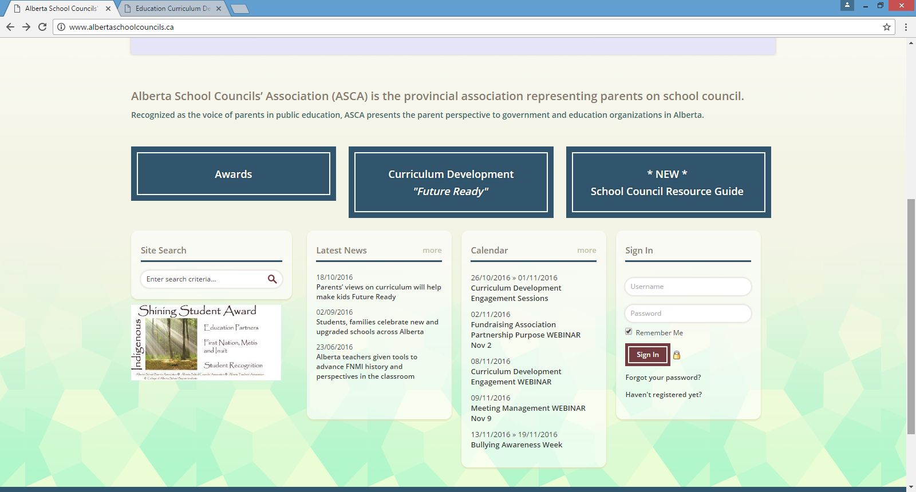

  - Other

- Mailbag - empty
- Next Meeting – January 12, 2017
- Adjournment at 9:30 pm

