Mecca Glen School
Together We Are Making A Difference

Wolf Creek Public Schools

Shannon Quapp
School Council Chair
RR #1 Telephone (403) 783-2463
Ponoka, AB Fax (403) 783-6666
T4J 1R1

School Council Meeting Minutes
Wednesday, September 28, 2016 - 7:00 pm
In Attendance: Willem H., Chantel A., Evie V., Laureen S., Stacy W., Richard Z., Dan W., Tristan J., Shannon Q., Kari A., Adam T.

- Call to Order @ 7:12 pm

- Approval of Agenda - Tristan motioned to approve agenda as amended, Nicole seconded. Please add: #4 Business arising from last meeting; 10 K - Grade 9 trip to the Legislative building and 10 L - outside sign.

- Minutes From Last Meeting - Nicole motioned to approve minutes as presented, Stacy seconded.

- Business arising from last meeting:
Swimming lessons will be at Burman University in Lacombe this year, swimming lessons will only cost $1.00 more per student. We will try it for 1 year and see how it goes. The cost at Lacombe pool went up by a large amount this past year, so the school needed to look for other options. The Ponoka Pool was not very accommodating; they didn’t know how many instructors they will have or what times will be available.
Sigmund Brouwer is still available to students online this year.

- Treasurer’s Report – Stacy Waddell
General Chequing: $16,450.57
General Savings: $29,251.13
Casino Chequing: $6,670.43
Casino Savings: $3,387.83
Casino Date – Middle of January 2017

- Fundraising Society Report –Willem Huijssoon
Christmas Raffle - Dec
Coco Brooks – Feb
Bashaw Meats – March
Highway Clean-up – May
Casino – Sheri Kroening will organize but need lots of helpers, please volunteer!
A letter has been sent to Alberta Gaming to ask for an extension on the deadline to have the current Casino money spent, fundraising doesn’t think it will be an issue to have the date extended. The remaining casino money to be spent on – electronic building blocks, Lego robotics, AR test bank, basketball hoops, other sports equipment, science supplies. There is approximately $9.920.00 to be spent by January 1, 2017. November will be the next Fundraising Committee meeting.

- School Board Trustees’ Report – Donna Peterson – Presented by Richard Zandberg
August 25, 2016
Board Organizational Meeting
The annual organization meeting was held on August 25, 2016. The purpose of the meeting is to select a chair and vice chair to hold office through the 2016-2017 school year. Trustees also made appointments to their standing committees and external organization representations.
The Board selected Lorrie Jess to serve as chair and Pam Hansen was elected to the position of vice-chair.
Committee and other appointments will be posted to the Wolf Creek Public Schools website.
Annual Education Results Report (AERR) and Three-Year Plan
The Board received a presentation on the proposed format and content for the 2015-16 AERR and Three-Year Plan 2016-2019. The Board will be working with the Superintendent to revise and refine the document to ensure it reflects the goals and outcomes that are most beneficial to improving the learning opportunities for students in WCPS. The document must be approved and submitted to Alberta Education by November 30, 2016
Thought Exchange Webinar
The Board participated in a webinar on a software program known as “ThoughtExchange”. Thought Exchange is a specialized web-based product designed to facilitate the engagement of people in gathering input into board initiatives such as budget and future directions. The Board will consider the desirability of purchasing this engagement tool at the September 15, 2016 regular board meeting. The cost of the program is $54,000 and covers an initial period from September 2016 to August 2019.
Board Self-Evaluation: A Positive Path Forward
On August 24, 2016, the Board engaged in a full-day workshop to complete a self-evaluation process and review both the role of the Board and the Superintendent as outlined in district policy. Dr. Leroy Sloan, consultant with the Alberta School Boards Association, facilitated this process. Five priorities for the
superintendent were developed for the 2016-2017 school year. These five priorities are designed to create a positive path forward:
- Increasingly focus on performance metrics when deliberating issues and direction of the school division. This is consistent with board policy, which says the Board is to make data-driven decisions that ensure our students achieve at the highest level.
- Enhance communication to staff and communities to inform and celebrate the ongoing direction of WCPS.
- Develop and implement direct input opportunities from staff and community members to guide the development of the Three-Year Plan.
- Strategize means to increase board awareness and understanding of the impact of board decisions on student learning at the school level.
- Clarify for staff and communities the role of the Board.
September 15, 2016
World Teacher Day
World Teacher Day is set for October 5, 2016. WCPS recognizes the contributions made by our teachers to ensuring the highest quality learning for our students and thanks all of our school based staff for their efforts.
Mission and Vision Statement
Trustees considered the status of the current Mission and Vision statements for WCPS. Superintendent Lovell has been requested to undertake a review process to update the Mission and Vision statements to ensure they accurately reflect the current direction and reality of WCPS. The process will seek to gather input from as many areas of the jurisdiction as possible to ensure the statements reflect fully the new directions and areas of focus for WCPS.
Enrolment and Budget Update
Superintendent Lovell, Secretary-Treasurer Henderson and Assistant Secretary-Treasurer Hall provided an update on the preliminary enrollment and budget situation. Based on enrolments in WCPS schools on September 9, 2016 it is projected that the Division will face a revenue shortfall around $357,000. It was also reported that the anticipated budget deficit from the 2015/16 fiscal period will be approximately $1.365 Million less than budgeted which will result in greater than projected accumulated operating reserves. Trustees considered priority use for the additional funds including the hiring of additional teaching staff, educational assistants and social workers in schools to address class sizes and student learning needs. The changes will be reflected in the revised operating budget that will be presented to the Board in November 2016.

- Playground Report – Kari Albers
Playground is finished, total cost was $106,094.79. There is approximately $6,770.00 left, which will be used for recognition of the donators - perhaps an outside sign, bench or a big rock. There will be a playground meeting in October.

- Principal’s Report – Dan Walker
Enrollment our current enrollment is at 130 students. This number is down 1 from last years count at this time. Class sizes dictated our grade configurations. We were able to maintain the items we felt were most crucial K and Grade 1 are separate for the majority of the day. We opted to combine the 8/9’s opposed to the ⅚’s because of the cycled curriculum and the fact that the current grade 8 class only has 8 students which dictates that the following year will be a combined 8/9 again.

Staffing
K - Mrs. Nickerson ( .8 FTE)
Grade 1 - Mrs. Ronnie
Grade 2 - Mrs. Stevenson
Grade ¾ - Mr. Zandberg
Grade 5- Mr. Erickson
Grade 6/7 Mr. Heppell (LA 6-9, Options) (.55 FTE)
Grade 8/9 Mr. Troitsky (Math and Science, Options)
Administrative Assistant - Mrs. Tristan Johnson
Caretaker - Mike Skaley

Mr. Zandberg is still in the designation of Acting Assistant Principal for the 2016/17 school year. Our inclusion coach will remain Shawna Johnson, she rotates her time between Alix, Clive and Mecca. Her primary role is to help create, implement and work with staff and students that are on adapted, modified or behaviour plans. Our SSW is Ms. Amber Harris and she is at the school Mondays, Thursdays and every other Friday
We have three EA’s working with our students currently. We were allocated time for 2 full time positions but to serve the needs of our students we split the time to provide support to our students during the core classes. Mrs. Wiancko works at the school fulltime and Mrs. Scott, and Mrs. Shackleton each work the morning. This is a reduction of 1 EA position from last year. Both Mrs. Scott’s and Mrs. Shackleton’s positions are maternity leave replacements which go until May 2017.
School Focus
Our goal as a school this year is to continue to focus on literacy. We are spending the first month and a half gathering all of the data around literacy for each classroom. We are using STAR from Grade 2-9, Fountas and Pinnell for K - 3 and SRI for the grade 6-9. We are using this data to help identify exactly where students are in regards to literacy (fluency, comprehension, beginning sounds….) Our goal is to increase the overall literacy level within each classroom and the school. We have built time into the schedule outside of regular Language Arts classes to address our concerns or provide extension activities. We have new resources ( Scholastic, READ 180) designed to help in literacy. As a staff we believe communication home is crucial which led to a third Parent Teacher interview night for the current year. We are also sending home Progress Reports at different intervals in the year ( Nov. 15th is the first) to try to maintain open communication with parents.
Technology
At the end of the last year we purchased a 3D printer, it has arrived and some staff got trained. Students are now able to print objects and are beginning to design their own creations. We still are able to maintain a 1 to 1 environment from Grade 3-9. Although each student has access to a device in these grades they are not used all of the time. Through the fundraising society we have also been afforded the funds to purchase some electric building blocks. This hands on learning opportunity will work for all grade levels and should be here next month. As always we are a BYOD environment and students who wish to bring a device from home are welcome.
Budget
Our school budget is similar to last year, we are still supported by the small class size funding and also receive some additional admin. Allocation for Richard to expand his role outside of our walls as a resource for partner schools. Like last year we will again prepare to maintain a balanced budget so we are not penalized the following school year. One of the area’s we were affected was in the Inclusive Ed. department. We are no longer funded for Level 3 students, only Level 4 students receive funding for EA support. We lost one fulltime EA due to these cutbacks.
September News
The Welcome Back BBQ was hosted on the 15th, the excellent weather affected the turnout but we still had a large number of parents attend. The volleyball teams are made and are well into their seasons. The golf team just finished their tournament yesterday, and today the cross country running team went to their meet at Deer Valley by Alix. The Terry Fox run is being held tomorrow (Sep. 29th) at 12:40 and all are welcome to attend.

- New Business
  - Recent/Upcoming School Activities – Terry Fox Run, Welcome Back BBQ, Book Fair, SLAs, … Book fair October 31 – Nov 4. SLA will not be done in Wolf Creek this year. Staff could be added to newsletter, picture and job description so families know who they are and what they teach/what their role is at the school.
  - Volunteer Survey Results – Great response this year, need a coordinator for smoothies yet.
  - Hot Lunches – Will be trying every 2 weeks mostly on Tuesdays
  - Gr. 9 Quebec Trip – Grade 9 trip, mostly likely will not be going to Quebec, cost has gone up, and new policies from Wolf Creek make it hard to go ahead with it. Looking into different trip options.
  - New bell times – please update online – this will be done shortly.
  - Nut free school discussion – No nuts at all please!
  - ACE plan – Mr Walker & Mr Zandberg will submit the ACE plan, a meeting will be set in October to discuss the ACE plan, please attend and voice your opinion.
  - Potential School Council Meeting Dates – Wednesdays- Nov. 2, Dec. 21, Feb. 1, Mar 15, Apr 26, May 31 (AGM) – only set Nov date, we will see in Nov about the other dates.
Laureen motions the next meeting will be Nov 2, 2016, Evie seconded.
  - Alberta Culture Days – Sept 30 – Oct 2 – working on building a multi cultural day, having a few speakers and presentations. It will not take place during Alberta Culture Days.
  - Grade 9 Field Trip to Legislative building – the now grade 9 students missed going in grade 6, wondering if they would be able to go this year with the grade 6’s, or on their own trip, or take Grade 6 – 9; or make it part of the Grade 9 trip - staff will talk about it. Perhaps fundraising could help with the costs.
  - Outside sign – update every week or 2 depending on what’s happening
  - School Council E-News:
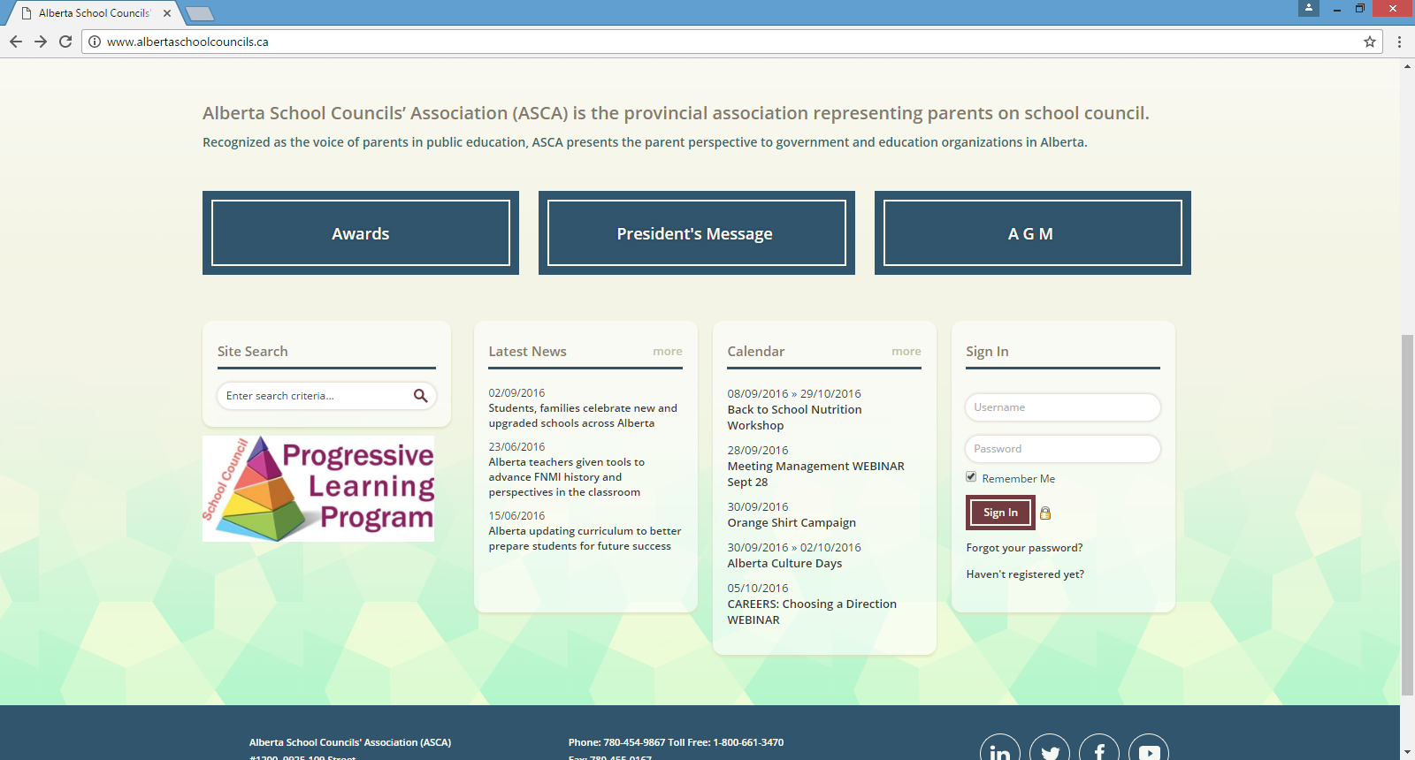
  - Other

- Mailbag - empty
- Next Meeting –Nov. 2, 2016 7 pm
- Adjournment @ 8:35 pm

